**WR110 User Manual**

Version: V1.01

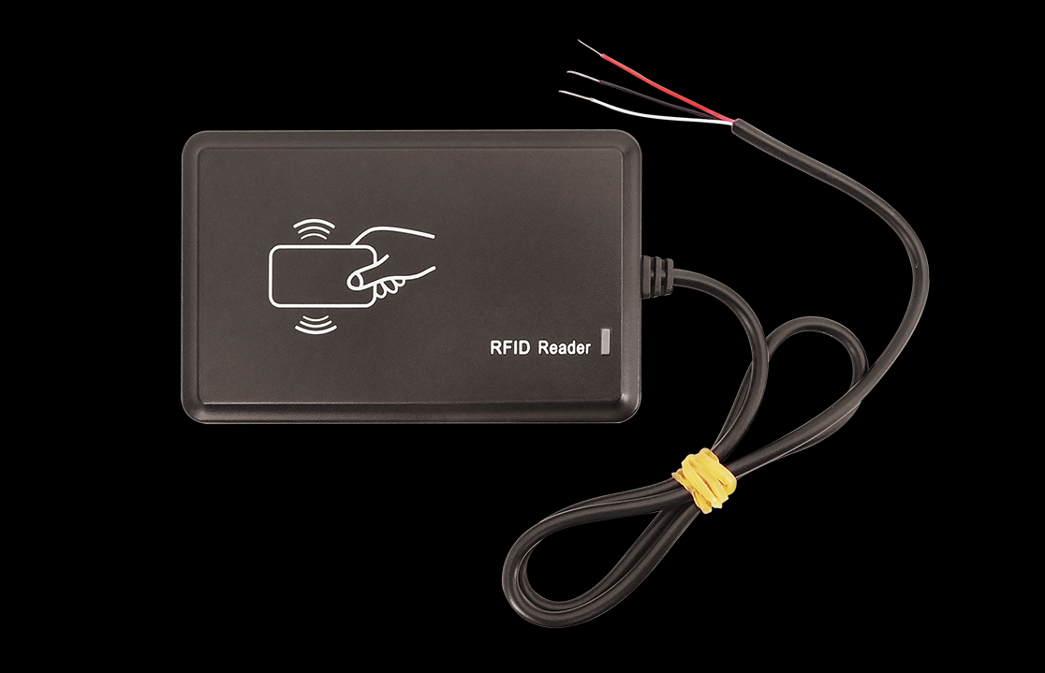

1.General Description

**64-Bit Lasered ROM:**

Each WR110 contains a unique ROM code that is 64bits long. The first 8 bits are a 1-Wire family code. The next 48 bits are a unique serial number. The last 8 bits are a CRC of the first 56 bits. See below Figure for details.

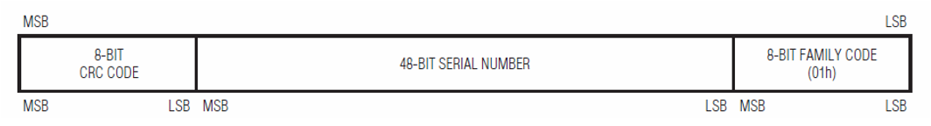

The 8bit family code of WR110 is 0x01.

The WR110 support 2 format card types ISO14443A(include Mifare and LEGIC), and ELID.

The ELID card data include facility code and card number, the length of facility code is one byte, the length of card number is four bytes that range from 00000000 to FFFFFFFF. the insufficient will make up for 0. For example: if the facility code is 0x0B, the card number is 0007864739‬, so the serial number is “0B007801A300“.

2.Parts List

|  |  |  |  |
| --- | --- | --- | --- |
| **Name** | **Picture** | **Dimensions** | **Weight** |
| WR110 | C:\Users\49459\AppData\Roaming\Tencent\Users\494591140\QQ\WinTemp\RichOle\3RQ)MT8HFOU$YD$C]$U[0O2.png | 95*60*12 mm | 78grams (MAX) |
| RF Card | C:\Users\49459\AppData\Roaming\Tencent\Users\494591140\QQ\WinTemp\RichOle\BOP68GDC[G%UGDJ0MPO4T]H.png | 85.6*54*0.9 mm |  |

3. RFID Specification

|  |  |  |
| --- | --- | --- |
| **NO** | **Type** | **Specification** |
| 1 | Standards | Comply with ISO1443A (include Mifare and LEGIC)standard and ELID Proximity. |
| 2 | Frequency | 13.56MHz | 125KHz |

4.Electronic Condition

|  |  |  |  |
| --- | --- | --- | --- |
| **NO** | **TYPE** | **SPECIFICATION** | **Unit** |
| 1 | Operation Temperature | -20~+80 | ℃ |
| 2 | Storage Temperature | -20~+85 | ℃ |

5.Light Indicator

WR110 have one led that is two color lamp, red color is power led, blue color flash three times that express send data success.

6.Power Connection

VIN (PIN1)/GND (PIN2) are the power input pins. The input voltage range for this device is from 7V to 32V. The device is designed to be installed in vehicles that operate on 12V or 24V systems without the need for external transformers.

7.Installation

**WR110 3Pin Output Interface:**

|  |  |  |  |
| --- | --- | --- | --- |
| **WR110** | **Pin Names** | **color** | **Description** |
| **3Pin**  **1wire**  **Interface** | **VDD** | RED | WR110 power support 7V~32V. |
| **GND** | BLACK | Ground |
| **1wire** | WHITE | 1-Wire data |

8. Supported RF Card

|  |  |  |  |
| --- | --- | --- | --- |
| **Type** | **Manufacturer** | **Model** | **Operation distance** |
| Supported RFID card | MIFARE | MIFARE Mini,  MIFARE Ultralight,  MIFARE- DESFire EV1,  MIFARE Plus,  MIFARE ONE(S50),  MIFARE ONE(S70),  MIFARE Pro(X) | 30mm |
| LEGIC | LEGIC 4K capacity Card  LEGIC 2K capacity Card  LEGIC multi-protocol Card  LEGIC Credit card | 20mm  35mm  13mm  10mm |
| ELID | ELID Proximity Card | 30mm |